TECHNO ENGINEERING SERVICES (PVT.) LIMITED

***ENGINEERS & CONTRACTORS***

*Ref No. Emp-4092 Dated: <To2>*

**TO WHOM IT MAY CONCERN**

It is certified that Mr. <Name> S/O <fname> has worked with us as a “<Designation>” from <From2> to <To2> in Enter Refinery Pipe Line Project (U.A.E) Abu Dhabi.

He proved to be a diligent worker, knowledge in his job and cooperative. He would be an asset to any company to his present position.

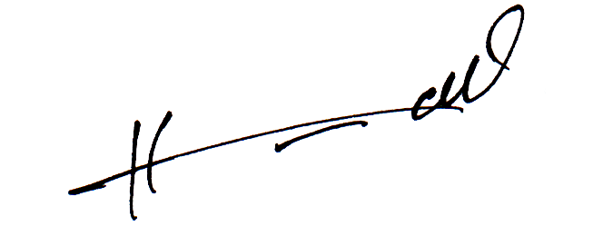

***ISSUING AUTHORITY***

**House No. 30, Street No. 19, F-6/2, Islamabad, Operating Office at Plot No. S10204, Jabel Ali Free Zone, P.O. Box 261401, Dubai Head Office at Mezannine-1, Faloutha Building, Hamdan Street, P/O Box 105424, Abu Dhabi**